BSI.IT.10.C19 – Server Protection – CDA (2026)
IT RCSA – Configuration Management
Item | Detail
Control | BSI.IT.10.C19 – Server Protection (Heracles 50539667)
Risk | [BSI.IT.10.R6 Malicious Software] Systems are compromised due to failure to detect malicious software which may result in unauthorized access to network and data, business and operational disruptions, financial loss, and regulatory noncompliance. (High)
Owner / executor | Ian Rojo
Relevance / nature / frequency | Key Control / Hybrid / In every operation
Testing period | 07/05/2025 – 07/04/2026
Prepared by / reviewer | Edward Morfa (IT RCSA) / Amanda Munoz Henry (Testing Manager)
Evidence | Folder BSI.IT.10.C19 Server Protection/Evidence – files start with their E-number. Screenshots in Evidence/Screenshots.

Control statement
[BSI.IT.10.C19 Server Protection] In every operation and upon imaging of a server, Infrastructure Engineering installs Endpoint Protection on the server to mitigate the risk of any malicious software. Exceptions to disable malware protections on server are approved by the CISO (or delegate).
How to read this: each question has the answer first, then the reason, then where to look. 'E04d line 15' means evidence file E04d, line 15. 'E01 p.12' means page 12 of E01.
Evidence used
Ref | What it is
E01 | Virus and Malware Protection Standard v5.2, approved 05/28/2025 – SUS.VMPS.4.2.3.1-4.2.3.3 (p.7), sec. 6 Exceptions (p.9)
E01a | Same Standard v6.0, approved 07/28/2026 (after the period)
E02 | Linux Red Hat Hardening Guide v3.0 – 4.1 CrowdStrike installed (p.6)
E03 | BigFix screenshot 11/03/2026 – permanent action 00-126993 that installs CrowdStrike on Windows
E04 | Linux CrowdStrike manual install procedure
E05 | CMDB extract 11/04/2026 – 5 rows, all created April 2025
E06 | SEF exceptions approved 07/01/2025 – 07/04/2026 – the file is empty
E07 | Coverage period calculation
E08 | WP2 C19 2025 (prior year)

Testing period
Annual test. The 2025 test covered 10/01/2024 – 07/04/2025, so this one starts 07/05/2025 (Testing Procedure 4.4.2; E07). C19 was rated effective three times in a row (tab 24 Mos). The period ends after the Test Plan window, so the population is pulled through the request date and any rest rolls into the next period (E07 note).
Design questions
1. Is the control designed with an appropriate frequency or trigger?
Yes. Windows: the CrowdStrike sensor is in the server image, and BigFix action 00-126993 is a permanent action that never expires and reinstalls the sensor on any domain machine where it is missing (members: Servers Miami, Servers Virginia, Workstations). Linux: the admin installs the sensor by hand during the build (E04). Install at build plus a standing BigFix check is the right trigger.
Reference: E03; E04
2. Is there a defined audit trail/evidence which supports the execution of the control being performed?
Yes. BigFix keeps the action status and the computers it ran on; the Falcon console keeps first-seen dates per host; Linux install can be shown with 'ps -e | grep falcon-sensor' or the console. CMDB gives the build dates.
Reference: E03; E04
3. Is the control aligned with internal policies and/or applicable regulations?
Yes. SUS.VMPS.4.2.3.2 and 4.2.3.3: every applicable device needs EDR, running continuously on all servers (E01 p.7). Exceptions need Santander US CISO approval (E01 sec. 6, p.9). The Linux guide lists CrowdStrike installed (E02 p.6).
Reference: E01 p.7, p.9; E02 p.6
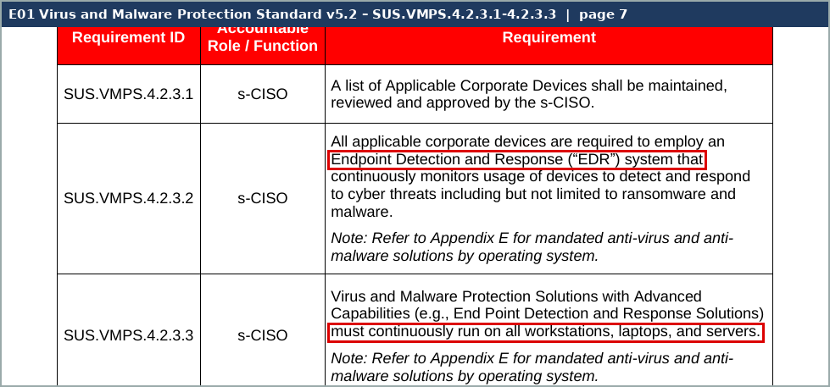
Screenshot 1 – C19_S4_VMPS_4.2.3.png (Evidence/Screenshots)
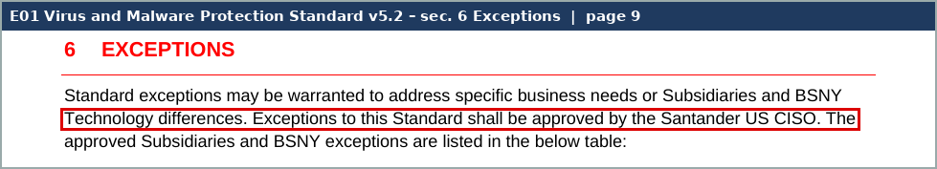
Screenshot 2 – C19_S6_VMPS_exceptions.png (Evidence/Screenshots)
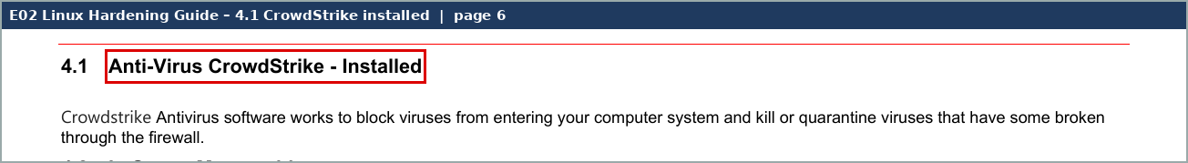
Screenshot 3 – C19_S5_Linux_CS.png (Evidence/Screenshots)
4. Are the thresholds for execution/resolution appropriate?
N/A. Not required – Key control.
5. To what level is the issue escalation process defined and implemented?
Full. Same as 2025: servers without the agent get a ServiceNow ticket; an agent that cannot be installed needs a SEF exception approved by the CISO. None were approved in the period (E06).
Reference: E08 CDA Q5; E06
6. How reliable is the information which the control is dependent upon?
Moderately Reliable. BigFix is system-generated and dated. The Linux install is manual. The CMDB extract we got has 5 rows from April 2025, so it does not give the period population.
Reference: E03; E05
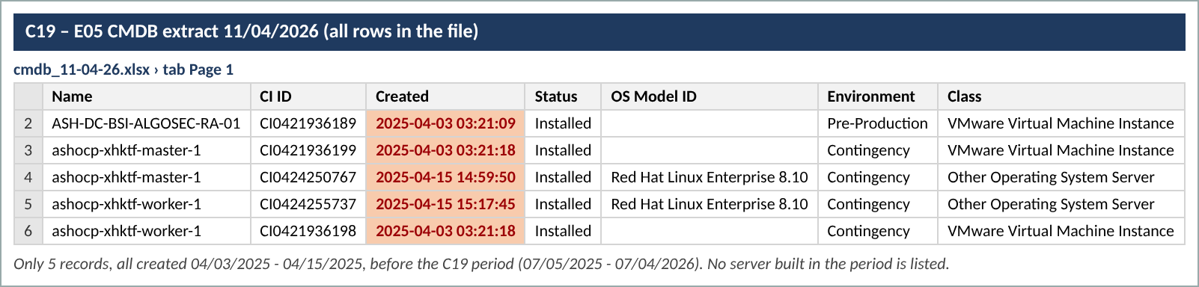
Screenshot 4 – C19_S3_CMDB.png (Evidence/Screenshots)
7. Is the process to obtain evidence of the control execution simple?
Yes. BigFix and Falcon console screenshots and a CMDB query are quick to produce.
Reference: E03
Walkthrough and sample of one
Walkthrough: [date and attendees to be confirmed – in 2025 the walkthrough was 06/06/2025 with Yamel Perez and Susan Menig]. Yamel Perez left on 04/10/2026; confirm the new Linux build owner.
How it works. Windows servers are built from an image that already has the CrowdStrike Falcon sensor. BigFix checks in with every machine daily, and permanent action 00-126993 pushes the sensor wherever it is missing. Linux servers are built by hand: the admin gets the CID and settings from InfoSec, installs the rpm, sets the CID and starts the sensor, then checks it with 'ps -e | grep falcon-sensor' or in the console (E04). InfoSec watches the console for gaps.
Sample of one – BigFix action 00-126993 (Windows)
What we checked | What we saw | Where | Result
Action exists and is live | !!!...PERMANENT ACTION...!!! SOFTWARE_DEPLOYMENT_CROWDSTRIKE_WINDOWS_SENSOR, state Open | E03 (C19_S1, S2) | Pass
Never expires / reapplies | 'This action will never expire'; reapplied an unlimited number of times; retried up to 5 times | E03 | Pass
Targets servers | Member actions 00-126994 Servers (Miami), 00-126995 Servers (Virginia), 00-126996 Workstations & Laptops | E03 | Pass
Result | 100% completed – 25 of 25 applicable computers (26 reported) | E03 | Pass
Owner of the action | Issued 11/19/2024 by MIAYPER@pb-santander.com – Yamel Perez, who left 04/10/2026 | E03 | Observation

The Windows auto-install works as described. The action still sits under the account of a person who has left; the team should confirm it keeps running and move it to a service or current admin account.
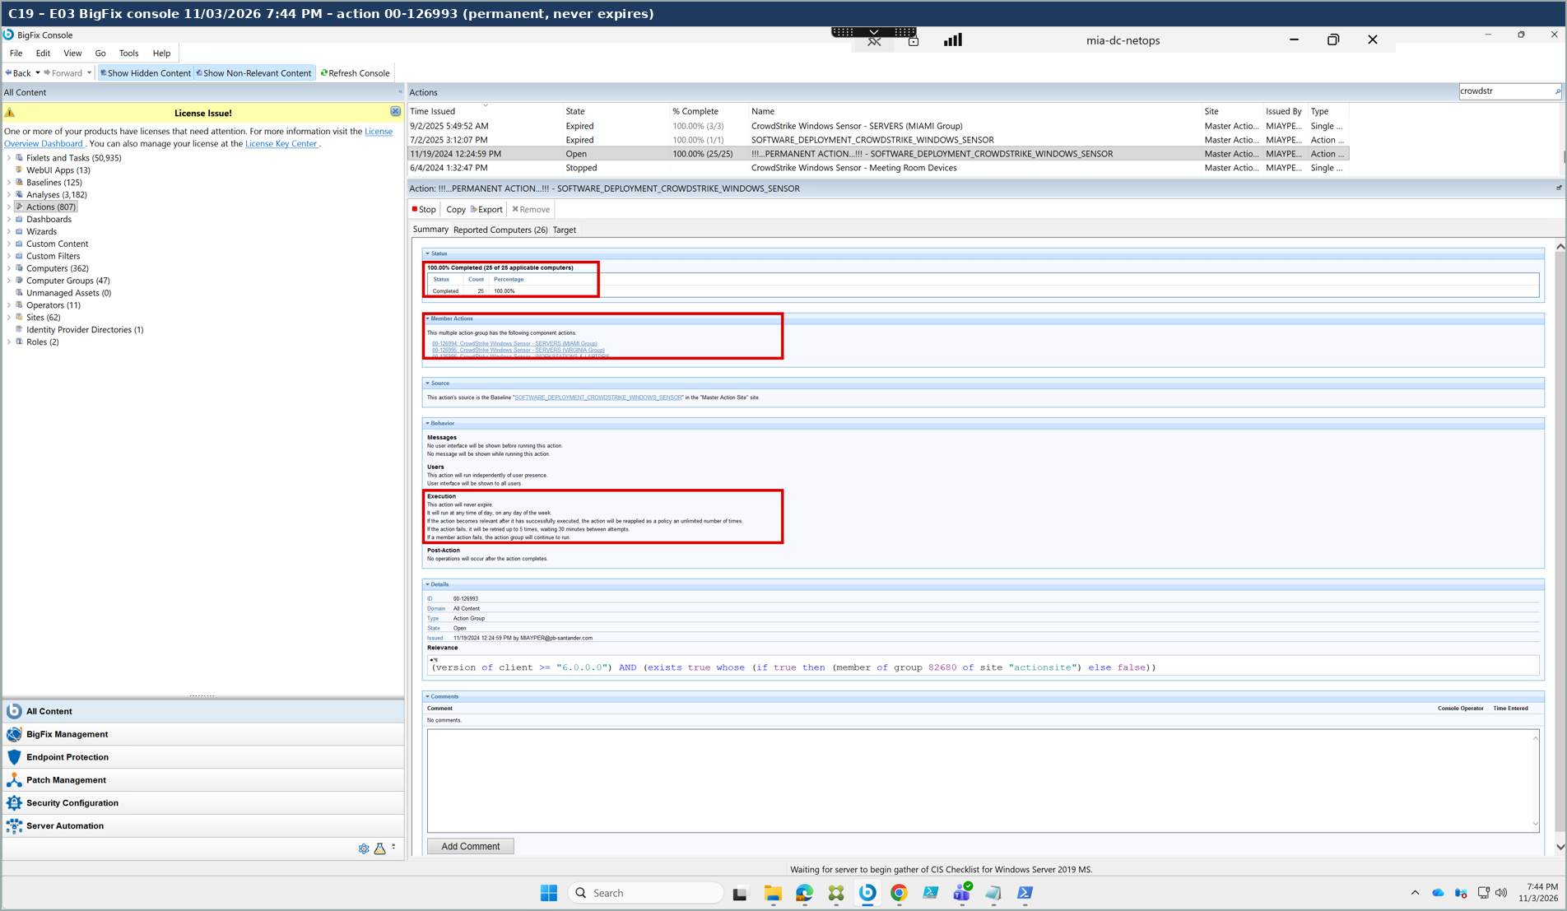
Screenshot 5 – C19_S1_BigFix.png (Evidence/Screenshots)
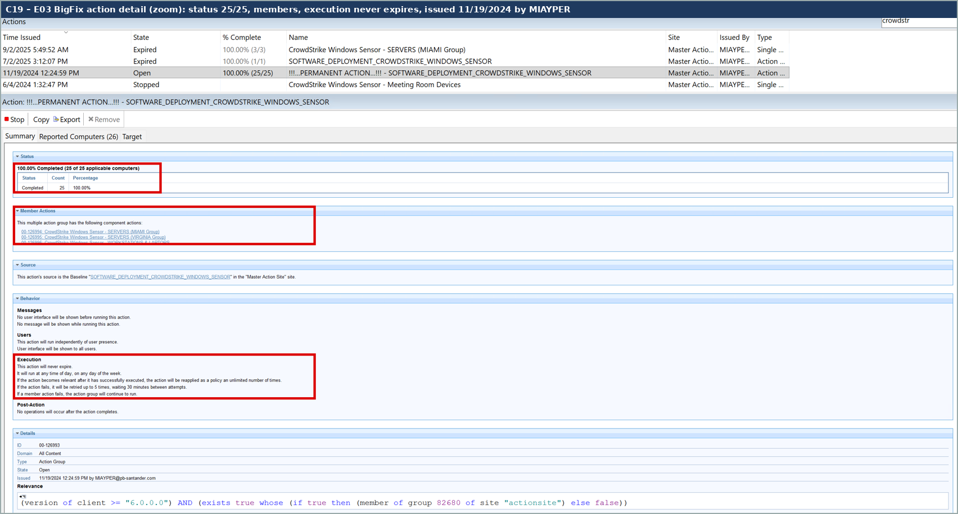
Screenshot 6 – C19_S2_BigFix_zoom.png (Evidence/Screenshots)
Design observations
- (1) BigFix action 00-126993 was issued by MIAYPER (Yamel Perez, left 04/10/2026). Confirm ownership moved.
- (2) Linux install is manual with no system check we have seen for the period.
- (3) The CMDB extract provided is not filtered to the period (5 rows from April 2025).
- (4) BigFix shows 25 applicable / 26 reported computers against 362 in the console; ask how the relevance group is built so no server is left outside it.
Calculated rating: Satisfactory
The design fits the risk: the sensor is in the Windows image, BigFix fixes any gap every day, and Linux has a documented install step. Aligned with SUS.VMPS.4.2.3.2-4.2.3.3. Calculated rating Satisfactory (Hybrid cap).

